**Smart Door Lock**

***A report submitted in partial fulfilment of the***

***requirement for the award of degree of***

***BACHELORS OF ENGINEERING***

***in***

***___Computer Sciencespecialization in Information Security___***

***Submitted By***

**Aditya Shinde – 19BCS3548**

***Under the guidance of***

**Mr. Anshul Sharma**

**Mr. Divneet Singh Kapoor**

**Mr. Khushal Thakur**

**Assistant Professors, Academic Unit – 1**



**Academic Unit-1**

**UIE, Chandigarh University**

**Table of Contents**

List of Figures………………………………………………… i

List of Tables…………………………………………………. ii

Abstract……………………………………………………….. iii

Chapter 1. Problem Identification……………………………. 1

Chapter 2. Feature Finalization……………………………….. 2

Chapter 3. Design Flow………………………………………. 3

Chapter 4. Simulation and outcome…………………………... 4

Chapter 5. Conclusion and future scope……………………… 5

References (If Any)…………………………………………… 6

Cost Analysis………………………………………………….. 7

Archives Project Submission Form…………………………… 8

List of Figures

Figure 1.1: Circuit Diagram…………………………………….

Figure 1.2: Block Diagram…………………………………….

**List of Tables**

Table 1.1: Cost Analysis ………………………………………………

**Abstract**

*To solve socio-logical security problems by use of technology we are advancing the locks.The use of I.O.T in appliances has growth vastly in these days.. Everyone wants tobe as much secure as possible, an access control for appliancesforms a vital link in a security chain. TheArduino BasedPassword Protected Home Appliances is an access control system*

*that allows only authorized persons to access alocks. Thesystem is fully controlled by the 8 bit microcontroller ATmega328There is a keypad by which the password can be entered through it.When they entered password matches with the password stored in*

*the memory then we get access to the locks.*

# Chapter 1

**Problem Identification**

*To solve socio-logical security problems by use of technology we are advancing the locks.The use of I.O.T in appliances has growth vastly in these days. Thus we have introduced this technology in our project. Even the physical manually opening locks are there nut using smart lock is something better and secured.Also it has many other benefits like no need t carry aa key all the time or share the key causing travel and waiting As one could simply give access to lock by giving the password and which can be changed. This option of using the lock is one of the most convenient. The scope of electronic locks is expanding every year.*

# Chapter 2

**Feature finalization**

*It is more safe than our traditional key lock. In lock system we need not to carry key along with and fear to lost key and how to open it.it is password protected no one can open it. Keys and locks wear down over time it becomes more difficult to remain and function properly as they get jammed or rust in years. Keypad are much more durable than convenctionallocks.A high quality lock and keypad should last longer with Standard hardware.*

*The issues that may arrive with time in this setup are as follows:*

*Functionality Issues: As great as keypad locks are, occasionally there will be problems. Weather changes can cause the locks to malfunction, and glitches and other bugs can cause them not to work. It’s best to have a master key as a backup option for when technology fails.*

*Battery Power: Sometimes, your electronic keypad locks will be battery-powered. The batteries will last for six months and can go up to a year, but after that, they will need to be replaced.*

*The Potential for Hacking: Unfortunately, keypad locks can be compromised by hackers. If you are planning on using these locks, it’s a smart investment to step up your cybersecurity measures. It doesn’t happen often, but you can’t be too careful when it comes to your business.*

# Chapter 3

**Design Flow**

**Block Diagram**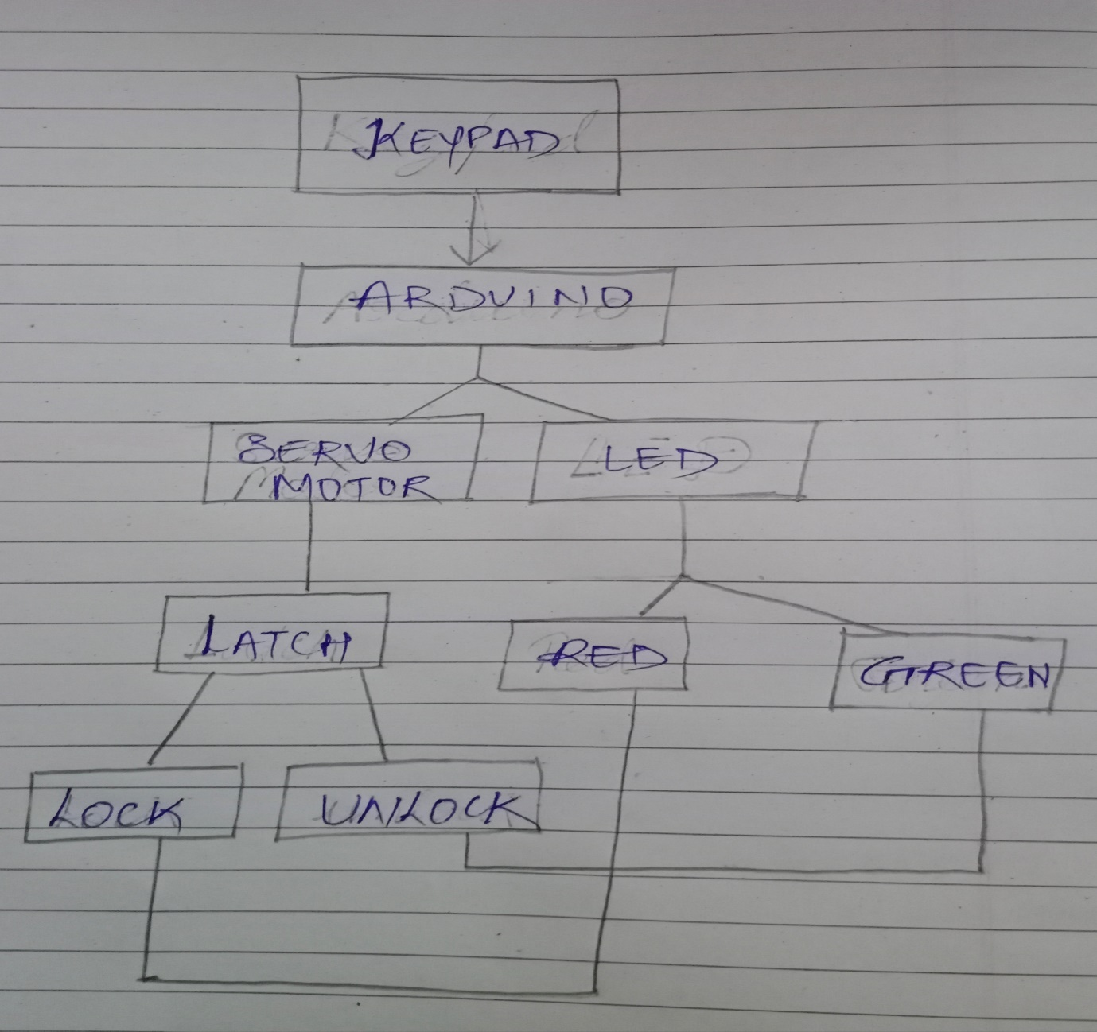

**Materials**

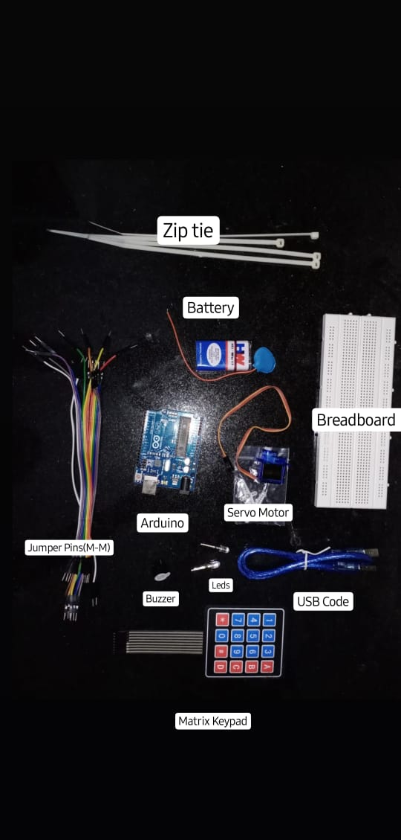

### **Arduino**:The Arduino Uno is an open-source microcontroller board based on the Microchip ATmega328P microcontroller and developed by Arduino.cc. The board is equipped with sets of digital and analog input/output pins that may be interfaced to various expansion boards and other circuits

### **Breadboard:** A breadboard is a construction base for prototyping of electronics. Originally the word referred to a literal bread board, a polished piece of wood used for slicing bread. In the 1970s the solderless breadboard became available and nowadays the term "breadboard" is commonly used to refer to these**.**

### **Servo Motor**:A servomotor is a rotary actuator or linear actuator that allows for precise control of angular or linear position, velocity and acceleration. It consists of a suitable motor coupled to a sensor for position feedback

### **Jumper Wire:**Jumper wires are simply wires that have connector pins at each end, allowing them to be used to connect two points to each other without soldering. Jumper wires are typically used with breadboards and other prototyping tools in order to make it easy to change a circuit as needed.

### **Matrix Keypad:** A Matrix keypad is the most commonly used input device in many of the application areas like digital circuits, telephone communications, calculators, ATMs, and so on. A matrix keypad consists of a set of push button or switches which are arranged in a matrix format of rows and columns

### **Buzzer:**A buzzer or beeper is an audio signalling device, which may be mechanical, electromechanical, or piezoelectric (piezo for short). Typical uses of buzzers and beepers include alarm devices, timers, and confirmation of user input such as a mouse click or keystroke.

### **Zip Tie:**A cable tie (also known as a hose tie, or zip tie, and by the brand names Ty-Rap) is a type of fastener, for holding items together, primarily electrical cables or wires. Because of their low cost and ease of use, cable ties are ubiquitous, finding use in a wide range of other applications.

### **Latch**: A simple door lock which is generally opened manually and used in Alimaris,Home Doors,etc

### **Battery:** A battery is a device consisting of one or more electrochemical cells with external connections provided to power electrical devices such as flashlights, mobile phones, and electric cars. When a battery is supplying electric power, its positive terminal is the cathode and its negative terminal is the anode**.**

# Chapter 4

**Simulation and Outcome**

**Circuit Diagram**

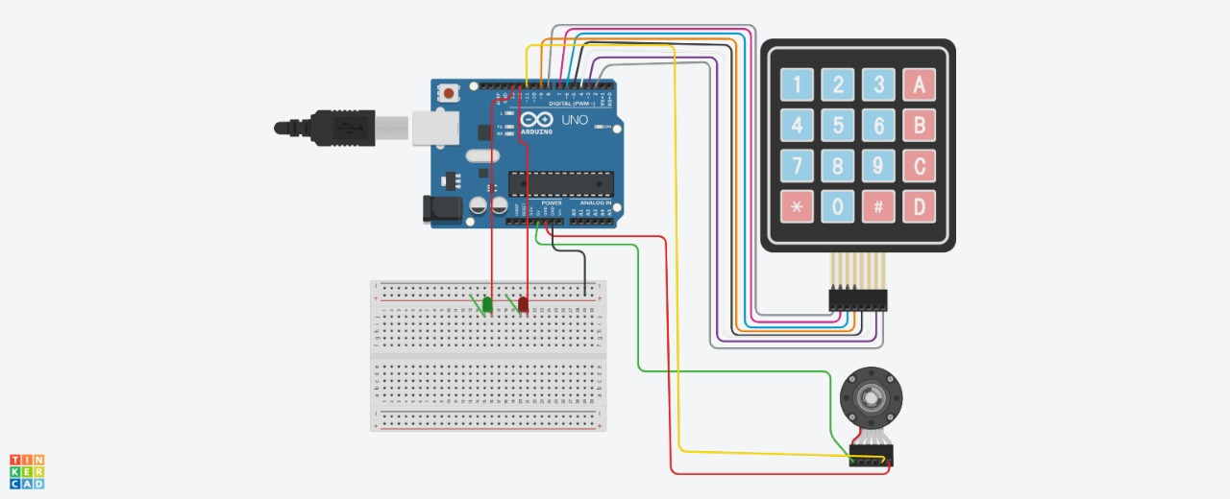

**Project lifecycle**

As the project title Indicates Smart Door Lock System. The lock is based on password protection. On completion we learnt and come across of process of construction of Digital Codes.

Lock which contained hardware and software development.We also know and understand the Arduino and its implement it on our project.

The biggest hurdle we had to overcome was interfacing the Arduino with the hardware components. And specially to code as per the requirements was creating mess.

Our digital code lock performed as expected.We are able to implement all the functions specified in our proposal.

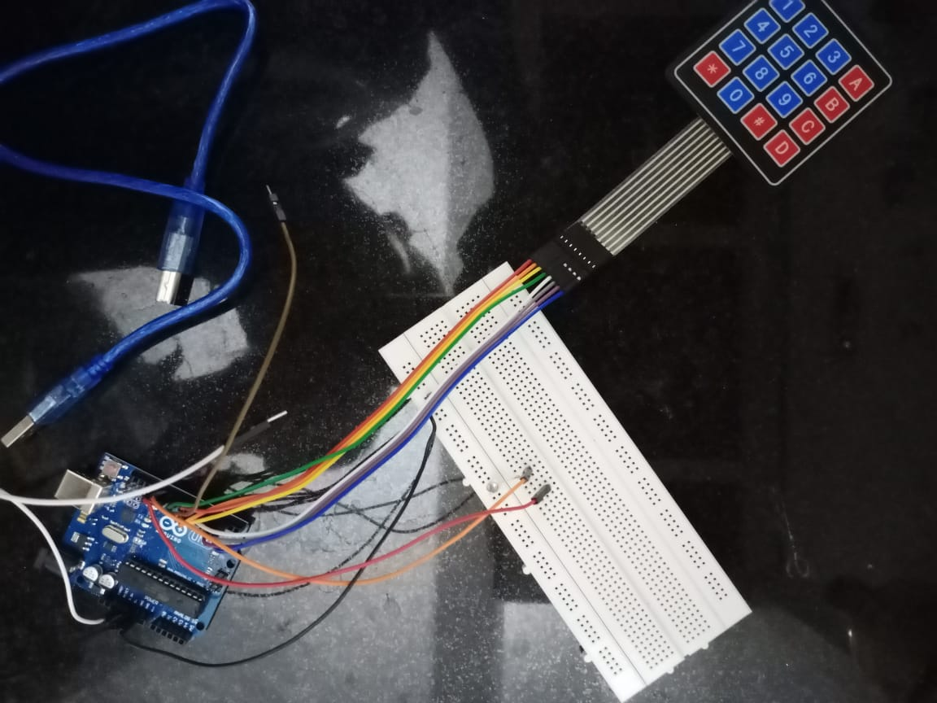

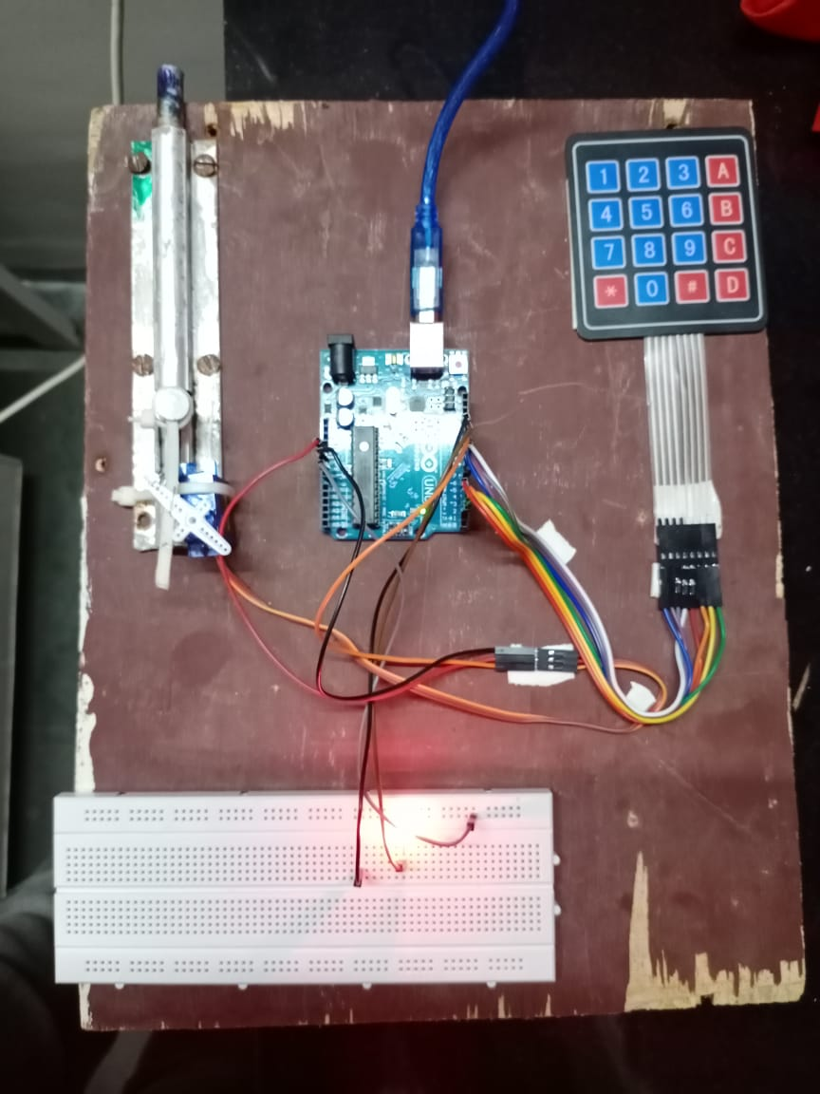

# Chapter 5

**Conclusion and Future Scope**

**Conclusion**

This digital code lock is particularly useful in application such as hotel room door locks, residential housing and even office buildings

When we completed this project, we had leamed and understand the process of constructing the Digital Code

Lock which contained hardware and software development. We also know and understand Arduino and how to implement it on our project. Our digital code lock performed as expected. We were able to implement all the functions specified in our project.

The biggest hurdle we had to overcome with this project was interfacing the microcontroller with the hardware components

**Future scope**

One of the most commonly used choices is to use an access code for an electronic lock. In this case, you do not need to carry a key or card regularly. It is enough to know the code of several numbers specified as a password. The user can independently set the access code and report it, if necessary, to trusted people. This option of using the lock is one of the most convenient. The scope of electronic locks is expanding every year.

**References**

1. **Link of reference**

<https://www.slideshare.net/hsahu9583/password-protected-door-opening-system-by-hemanta/>

<https://www.edgefx.in/projects-on-password-based-door-locking-system-using-microcontroller/>

1. **Research paper**

<https://pdfs.semanticscholar.org/e7a1/d6a40e3e92ca85f1a2a210d5b275afd01b60.pdf>

<https://www.irjet.net/archives/V6/i2/IRJET-V6I2225.pdf>

**Cost Analysis**

**Financial summary**

|  |  |  |
| --- | --- | --- |
| **SR NO** | **Components/Material/Services** | **Price ( RS.)** |
| 1. | Arduino | 400 |
| 2. | Bread Board | 70 |
| 3. | Servo Motor | 125 |
| 4. | Matrix Keyboard | 90 |
| 5. | Latch | 50 |
| 6. | Jumper Wires | 20 |
| 7. | 2x Leds | 4 |
| 8. | Zip Tie | 4 |
| **Total** |  | 763 |

**ARCHIVES PROJECT SUBMISSION FORM**

Project Code: **CU/Aug-2019/Sem__01__/UID______________ (To be filled by Office)**

Project Name: ________________________________________

Team Members:

|  |  |  |  |  |
| --- | --- | --- | --- | --- |
| **S. No.** | **Name** | **UID** | **Semester** | **Contact No.** |
| 1. |  |  |  |  |
| 2. |  |  |  |  |
| 3. |  |  |  |  |
| 4. |  |  |  |  |
| 5. |  |  |  |  |

**Section to be filled by team leader**

**Status (Please tick, whichever applicable)**

|  |  |  |  |
| --- | --- | --- | --- |
| Working |  | Not Working |  |

Team leader Details:

Name _______________________________ UID ______________________

Sign ________________________________ Date ______________________

**Section to be filled by Project Examiner(s)**

**Status (Please tick, whichever applicable)**

|  |  |  |  |
| --- | --- | --- | --- |
| Working |  | Not Working |  |

Project Examiner Signatures:

Internal _______________________________ Employee ID ______________

External _______________________________ Employee ID ______________

Date __________________________________